

# BSNEE TERMINATI0N NOTICE

Dear Customer:

Your license to BrightSign Network Enterprise Edition (“BSNEE”) software has expired due to your request to cancel the subscription, or has been terminated by BrightSign.

Section 5 of the BSNEE End User Terms and Conditions (the “BSNEE Terms”) provides that upon expiration or termination of the license, end user must cease any further use of the software and destroy any copies of the software or related documentation within end user’s possession and control and, upon BrightSign’s request, certify in writing that it has complied with such obligations. Per Section 5, BrightSign may also audit your equipment or premises to verify compliance.

Accordingly, we ask that you confirm your compliance with the BSNEE Terms by filling out and signing the attached Certificate of Compliance and returning it to our legal department at [legal@brightsign.biz](mailto:legal@brightsign.biz) with a copy to [finance@brightsign.biz](mailto:finance@brightsign.biz) and Rob Gardner, VP Product Operations at [rgardner@brightsign.biz.](mailto:rgardner@brightsign.biz)

You also acknowledge and agree that you will continue to be bound by the BSNEE Terms with respect to any retained BrightSign Confidential Information. We thank you for your speedy cooperation.

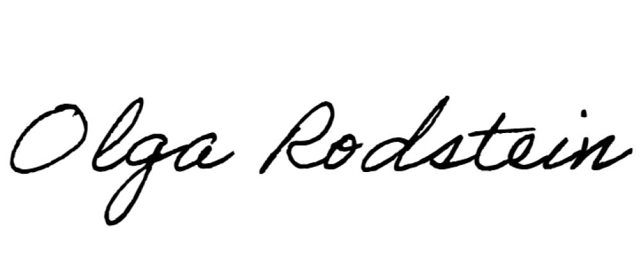Regards,

Olga Rodstein General Counsel [legal@brightsign.biz](mailto:legal@brightsign.biz)

Attachment

BrightSign LLC P.O.Box 320250, Los Gatos, California 95032 [legal@brightsign.biz](mailto:legal@brightsign.biz)

[CUSTOMER LETTERHEAD]

Date:

# VIA EMAIL

**To: Legal Dept.** [legal@brightsign.biz](mailto:legal@brightsign.biz) **With a copy to:**

[finance@brightsign.biz](mailto:finance@brightsign.biz) and

Rob Gardner, VP Product Operations [rgardner@brightsign.biz](mailto:rgardner@brightsign.biz)

# Re: Certification of Compliance

This letter is to confirm that our BSNEE license has expired or has been terminated. In accordance with Section 5 of the BSNEE End User Terms and Conditions, we confirm that we will cease any further use of the BSNEE software. We also certify that we have destroyed all copies of the BSNEE software that was in our possession or control, and any related documentation or other BrightSign confidential information. We acknowledge that BrightSign may audit our facilities or equipment to verify our compliance.

We further acknowledge and agree that we will continue to be bound by the terms and conditions of the BSNEE End User Terms and Conditions with respect to any retained BrightSign Confidential Information.

Sincerely,

[NAME and TITLE OF COMPANY AUTHORIZED REPRESENTATIVE; COMPANY NAME]